# Basic instructions for using the PLF_MAYA->LIGGGHTS scripts.

Create a scene.

Create a box that is equal to the volume of the total simulation. Call this ‘**SIMBOX1**’

Create a box that will be the insertion volume. Call this ‘**SIMINS1**’

*Both of the above simply provide max x/y/z coordinates for cuboid volumes. i.e. simulations must be in line with x/y/z worldspace. In the future I will aim to use the volume itself for non-cuboid insertion volumes. (simbox must remain x/y/z)*

Create a box to act as the tray, called ‘**tray**’. This should be the same size as the insertion volume

Indenters: **Long axis must be along X+.** For bird motion – create a cylinder where one tip sits at the origin and the other along the X axis.

e.g. I create a cylinder, then point constrain it to the ankle and aim constrain it to the knee. Repeat for all bones. Rounded caps help keep joints congruous, but rounded cap needs to be over the origin (i.e. pivot is at origin, but cap extends beyond). **Make sure this is the ‘0’ position – i.e. freeze any translations/rotatations/scale**

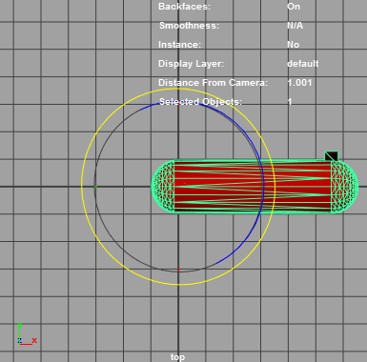

Now select your indenter[s], and run plfExport_Liggghts (best as a shelf button)

Cylinders used in place of bones must be arranged as point constrain to distal joint, aim constrain to proximal joint.

Bake Animation, and run euler filter in the graph editor. I may automate this in the future.